|  |  |  |
| --- | --- | --- |
|  | 以用户为中心 与商家共成长  User-Centered; Growing with Merchants | |
| RSA-S密钥对的生成与使用  Generation and Use of RSA-S Key Pairs | 密级：公开  Security Classification: Public |

**How to get the keys**

|  |  |
| --- | --- |
| **Writer** | **Updated** |
| **Technical Support Dept** | **2016-07-10** |

|  |  |  |
| --- | --- | --- |
|  | 以用户为中心 与商家共成长  User-Centered; Growing with Merchants | |
| RSA-S密钥对的生成与使用  Generation and Use of RSA-S Key Pairs | 密级：公开  Security Classification: Public |

# Run the software

Step 1: Unzip the and copy “openssl” file to your local disk, such as D disk:

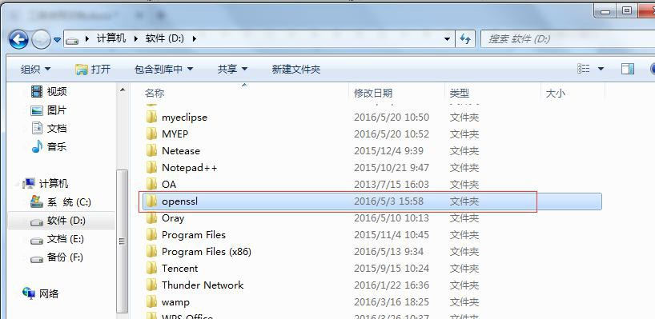

Step 2: run “cmd” command and open the command prompt window.

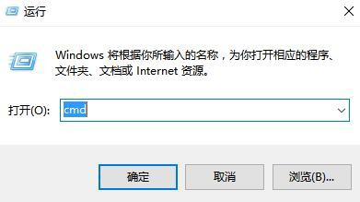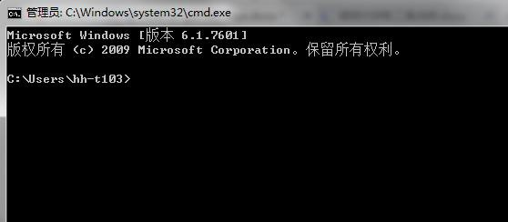

|  |  |  |
| --- | --- | --- |
|  | 以用户为中心 与商家共成长  User-Centered; Growing with Merchants | |
| RSA-S密钥对的生成与使用  Generation and Use of RSA-S Key Pairs | 密级：公开  Security Classification: Public |

# To generate the keys

|  |  |
| --- | --- |
| commands | Type the following four commands on CMD window(please copy those commands on  commands.txt if you don’t want to type)：  **cd /d D:\openssl\bin**  **openssl genrsa -out key.pem 1024**  **openssl rsa -in key.pem -pubout -out merchant_public_key.txt**  **openssl pkcs8 -topk8 -inform PEM -in key.pem -out merchant_private_key.txt -nocrypt**  If no error message,it means keys are generated sucessfully. |
| **merchant_p rivate_key** |  |
| **merchant_p ublic_key** |  |

|  |  |  |
| --- | --- | --- |
|  | 以用户为中心 与商家共成长  User-Centered; Growing with Merchants | |
| RSA-S密钥对的生成与使用  Generation and Use of RSA-S Key Pairs | 密级：公开  Security Classification: Public |

1. Using the keys

Open merchant_public_key.txt at first,then copy the contents between -----BEGIN PUBLIC KEY----- and -----END PUBLIC KEY-----：

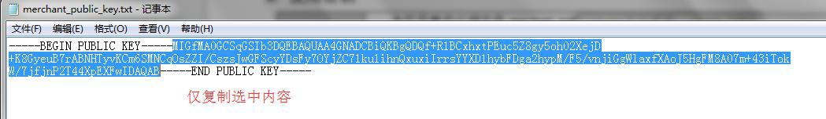

## merchant_publi c_key

Paste the contents on merchant system(upload the merchant_public_key)：

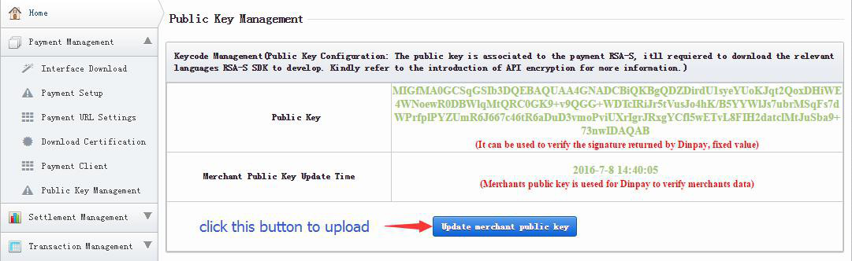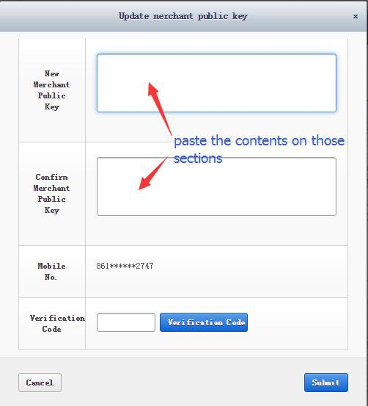

Click “Submit” to finish the upload.

|  |  |  |
| --- | --- | --- |
|  | 以用户为中心 与商家共成长  User-Centered; Growing with Merchants | |
| RSA-S密钥对的生成与使用  Generation and Use of RSA-S Key Pairs | 密级：公开  Security Classification: Public |

## merchant_privat e_key

Open merchant_private_key.txt(don’t edit it on this txt file)：

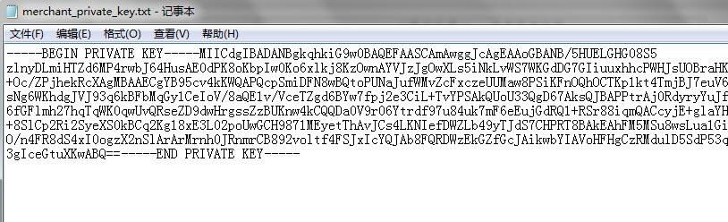

Using it as sample code does.